­­ Time management is a very important and highly beneficial skill to have in our lives. Since we have a limited amount of time, the art of using it the most efficient way to achieve our goals is valued very highly in our day-to-day professional and personal activities.

What makes a great time management? Most sources ([1], [3], [5], and [7]) indicated that a great time management consists of these four steps (specific terminology was taken from [7]):

1. Defining the activities

2. Sequencing the activities

3. Estimating activity resources

4. Developing and controlling the schedule

Defining the activities: To start working on something, a list of tasks to be accomplished is required first. Since it’s a beginning stage, task may be more high-level (without much detail) at first and details can be added later in the process ([7]).

Sequencing the activities: In order to know with which task to begin and to what tasks to proceed in the future, tasks should be put in order. Usually tasks are ordered based on their importance – from highest to lowest. There are two most popular strategies that might help you to decide on the order: the Pareto Principle and Eisenhower Matrix ([2]). The Pareto Principle refers to that usually 80% of our tasks take up 20% of our time. The remaining 20% of our tasks however, account for 80% of our work effort. Not all project related fall under your personal responsibility and, on the other hand, not all the tasks necessarily should be completed by a specific member of the team (assuming you work in a team). Lastly, in contrast to the feeling we sometimes get, not every task has to be completed immediately ([2]) Eisenhower Matrix addresses all those aspects and can help us to prioritize our work according to their urgency and importance.

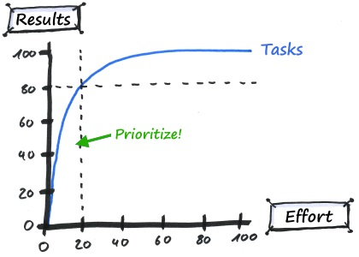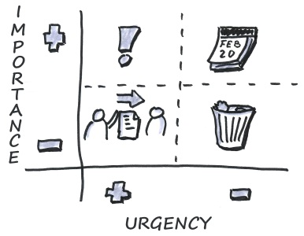

Pareto Principle (on the left) and Eisenhower Matrix (on the right)

([2])

Estimating activity resources:

Developing and controlling the schedule:

**Sources:**

[1] Linh Tran, “The Importance of Time Management (Aspects of Project Management Part 1)”, [https://www.inloox.com/company/blog/articles/the-importance-of-time-management-aspects-of-project-management-part-1/](https://www.cs.bgu.ac.il/~elhadad/se/psp1.html)

[2] Ariane von Berg, “Effective Time Management with Pareto and Eisenhower”, [https://www.inloox.com/company/blog/articles/effective-time-management-with-pareto-and-eisenhower/](https://www.cs.bgu.ac.il/~elhadad/se/psp1.html)

[3] Elizabeth Harrin, “Project Time Management Process Plan”, [https://www.thebalancecareers.com/what-is-project-time-management-3879177](https://www.cs.bgu.ac.il/~elhadad/se/psp1.html)

[4] Elizabeth Harrin, “Alternative to Gantt Charts”, [https://www.thebalancecareers.com/alternatives-to-gantt-charts-2779594](https://www.cs.bgu.ac.il/~elhadad/se/psp1.html)

[5] David H. MacDonald, “PMI/ESA project time management function”, [https://www.pmi.org/learning/library/time-management-project-functions-schedules-5723](https://www.cs.bgu.ac.il/~elhadad/se/psp1.html)

[6] Andreas Tremel, “Effective Time Management for Project Success”, [https://project-management.com/effective-time-management-for-project-success/](https://www.cs.bgu.ac.il/~elhadad/se/psp1.html)

[7] Jessie L. Warner, “Four Steps to Project Time Management”, [https://www.projectsmart.co.uk/four-steps-to-project-time-management.php](https://www.cs.bgu.ac.il/~elhadad/se/psp1.html)

[8] Ankit Rastogi, “10 Essential Time Management Strategies”, [https://www.greycampus.com/blog/project-management/ten-essential-time-management-strategies](https://www.cs.bgu.ac.il/~elhadad/se/psp1.html)

[9] Michael Elhadad, “Lecture 3: Time Management”, <https://www.cs.bgu.ac.il/~elhadad/se/psp1.html>